UNIT 2 LAB EXPERIMENTS
CSA-1610 DWDM
Program 1
# Covariance and Correlation
A <- c(18,2,20)
B <- c(22,28,10
C <- c(20,40,40)
data <- data.frame(A,B,C)
# Covariance between B and C
print(cov(B,C))
# Covariance Matrix
print(cov(data))
# Correlation between B and C
print(cor(B,C))
# Correlation Matrix
print(cor(data))
# Data Partitioning
values <- c(18,18,18,20,20,20,20,20,20,20,
21,21,21,21,25,25,25,25,25,
28,28,30,30,30)
# Equal frequency partition (bin size = 3)
bins <- split(values, ceiling(seq_along(values)/3))
print(bins)
# Bin Mean Smoothing
mean_smoothing <- sapply(bins,mean)
print(mean_smoothing)

# Bin Boundary Smoothing
boundary <- lapply(bins,function(x){
min_val <- min(x)
max_val <- max(x)
sapply(x,function(y){
if(abs(y-min_val)<abs(y-max_val))
min_val
else
max_val
})
})
print(boundary)
# Histogram
hist(values,
main="Histogram",
xlab="Values",
col="skyblue")
OUTPUT:
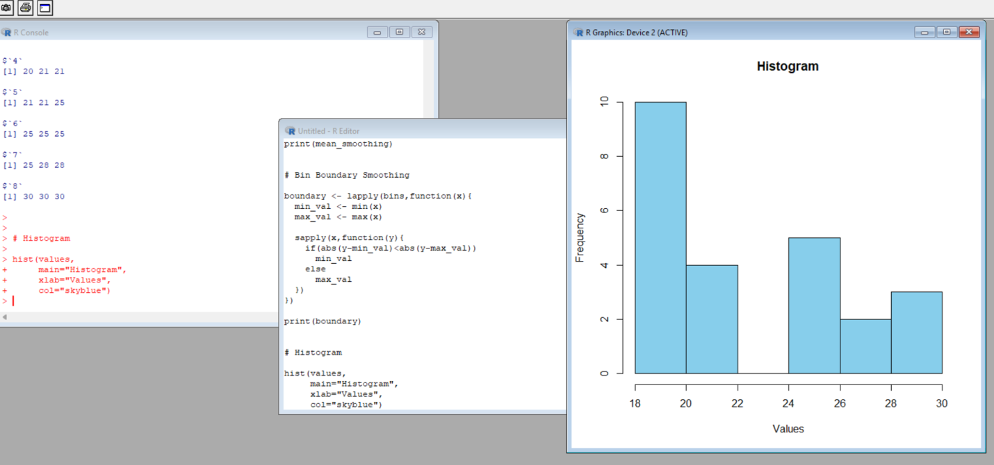

PROGRAM.2
price <- c(1,1,5,5,5,5,5,8,8,
10,10,10,10,12,14,14
14,15,15,15,15,15,15,
18,18,18,18,18)

hist(price,
breaks=10,
main="Electronics Price Distribution",
xlab="Price",
col="orange")
OUTPUT:
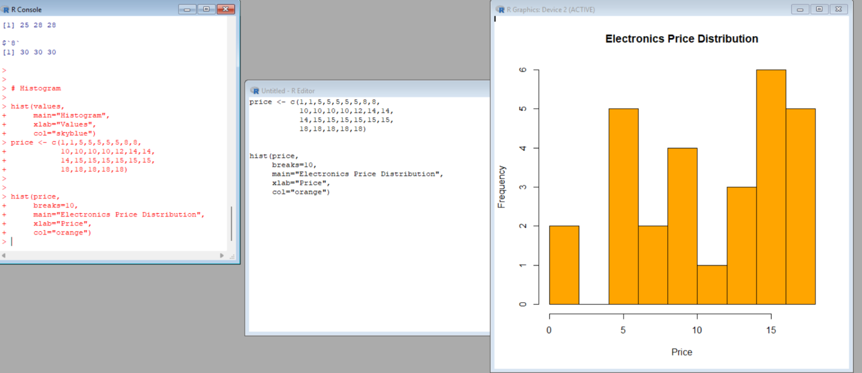
PROGRAM.3
ClassA <- c(76,35,47,64,95,66,89,36,84)

ClassB <- c(51,56,84,60,59,70,63,66,50)

# Mean
cat("Class A Mean:",mean(ClassA),"\n")
cat("Class B Mean:",mean(ClassB),"\n")

# Median
cat("Class A Median:",median(ClassA),"\n")
cat("Class B Median:",median(ClassB),"\n")
# Range
cat("Class A Range:",diff(range(ClassA)),"\n")
cat("Class B Range:",diff(range(ClassB)),"\n"
# Boxplot
boxplot(ClassA,ClassB,
names=c("Class A","Class B"),
main="Class Comparison",
col=c("blue","green"))
OUTPUT:
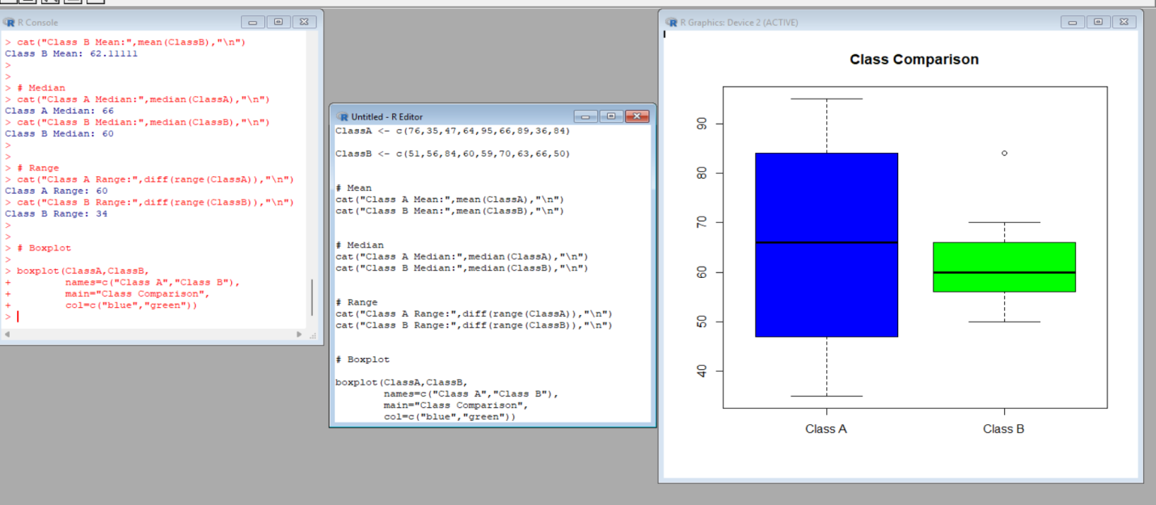PROGRAM.4
data <- c(200,300,400,600,1000)

# Min-Max Normalization
minmax <- (data-min(data))/(max(data)-min(data))
cat("Min-Max Normalization:\n")
print(minmax)
# Z-score Normalization
zscore <- (data-mean(data))/sd(data)
cat("Z-score Normalization:\n")
print(zscore)
OUTPUT:
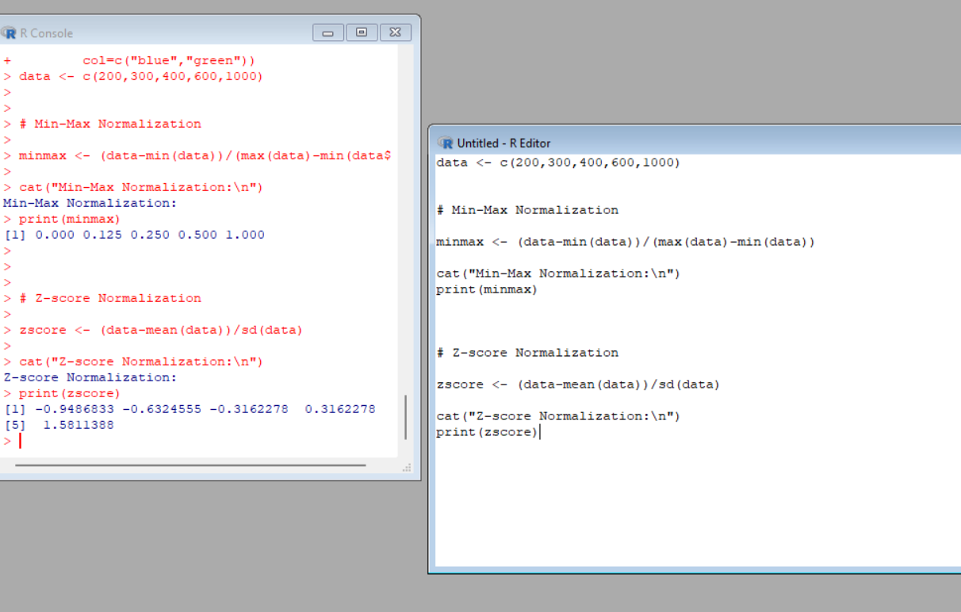
PROGRAM.5
data(AirPassengers)

hist(AirPassengers,
breaks=seq(100,700,150),
main="AirPassengers Histogram",
xlab="Number of Passengers",
col="purple")
OUTPUT:

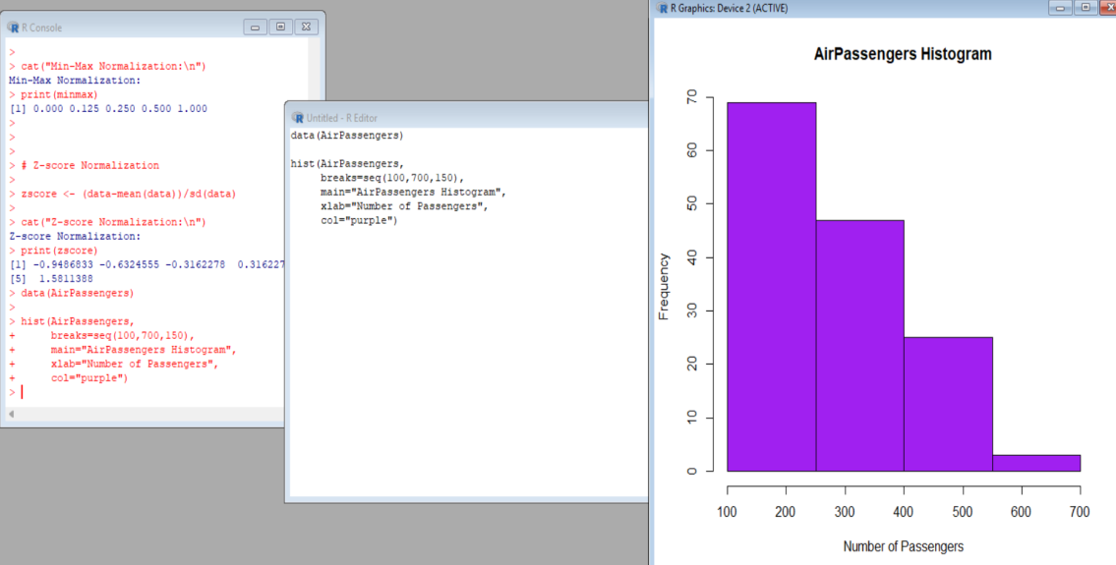
PROGRAM.6
data(mtcars)
plot(mtcars$mpg,
type="o",
col="blue",
main="MPG and QSEC",
xlab="Index",
ylab="Values")
lines(mtcars$qsec,
type="o",
col="red")
legend("topright",
legend=c("MPG","QSEC"),
col=c("blue","red"),
lty=1)

OUTPUT:
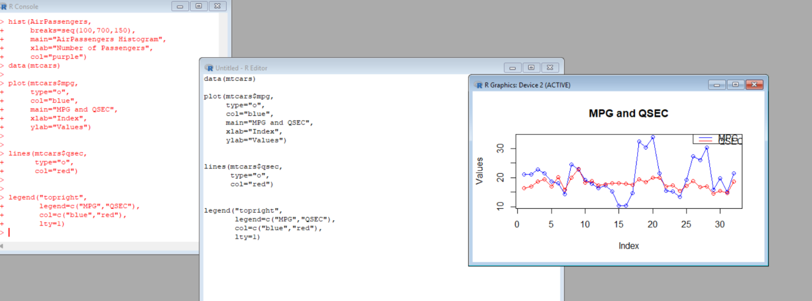
PROGRAM.7
data(water)
# Scatter Plot
plot(water$hardness,
water$mortality,
main="Mortality vs Hardness",
xlab="Hardness",
ylab="Mortality",
col="blue",
pch=19)
# Linear Regression
model <- lm(mortality~hardness,
data=water)
summary(model)
# Regression line
abline(model,col="red")

OUTPUT:
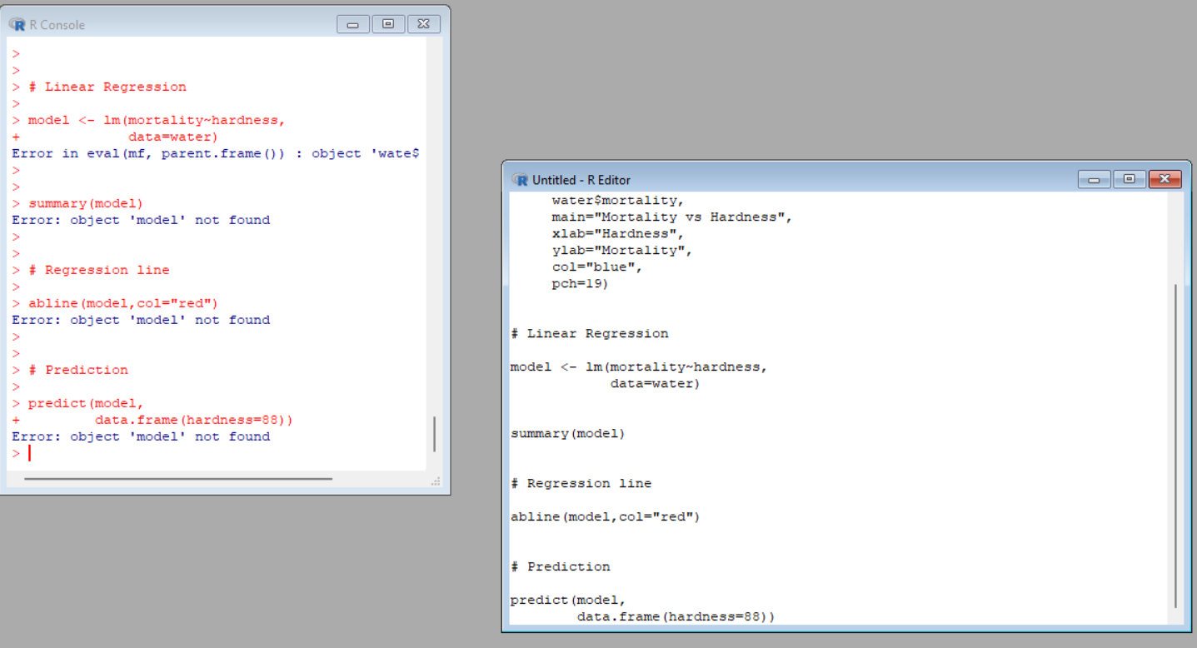
PROGRAM.8
data(mtcars)
boxplot(mpg~cyl,
data=mtcars,
main="MPG vs Cylinders",
xlab="Cylinders",
ylab="Miles Per Gallon",
col="cyan")
# Prediction
predict(model,
data.frame(hardness=88))

OUTPUT:
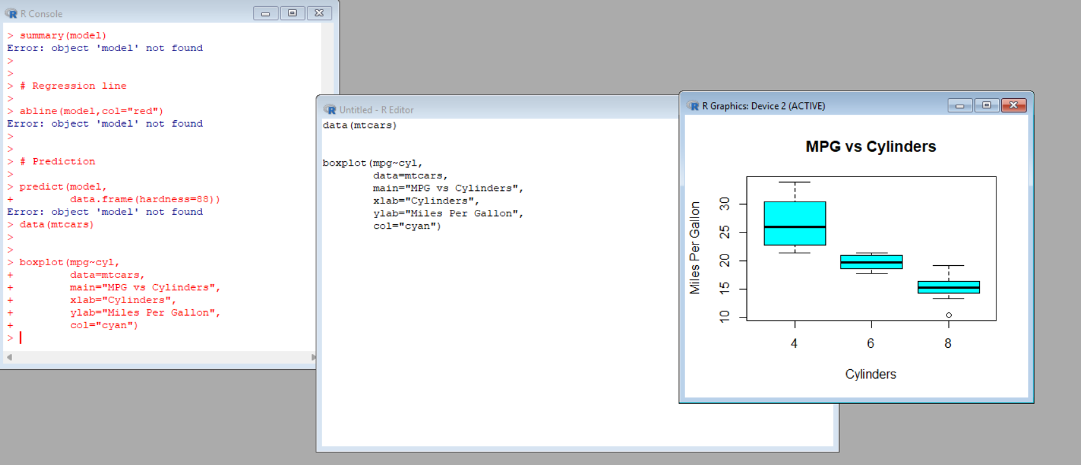PROGRAM.9
scores <- c(20,25,30,35,40,45,50,55,90)

boxplot(scores,
main="Tennis Player Scores",
ylab="Points",
col="yellow")

# Detect Outliers

outliers <- boxplot.stats(scores)$out

cat("Outliers are:")
print(outliers)
OUTPUT:
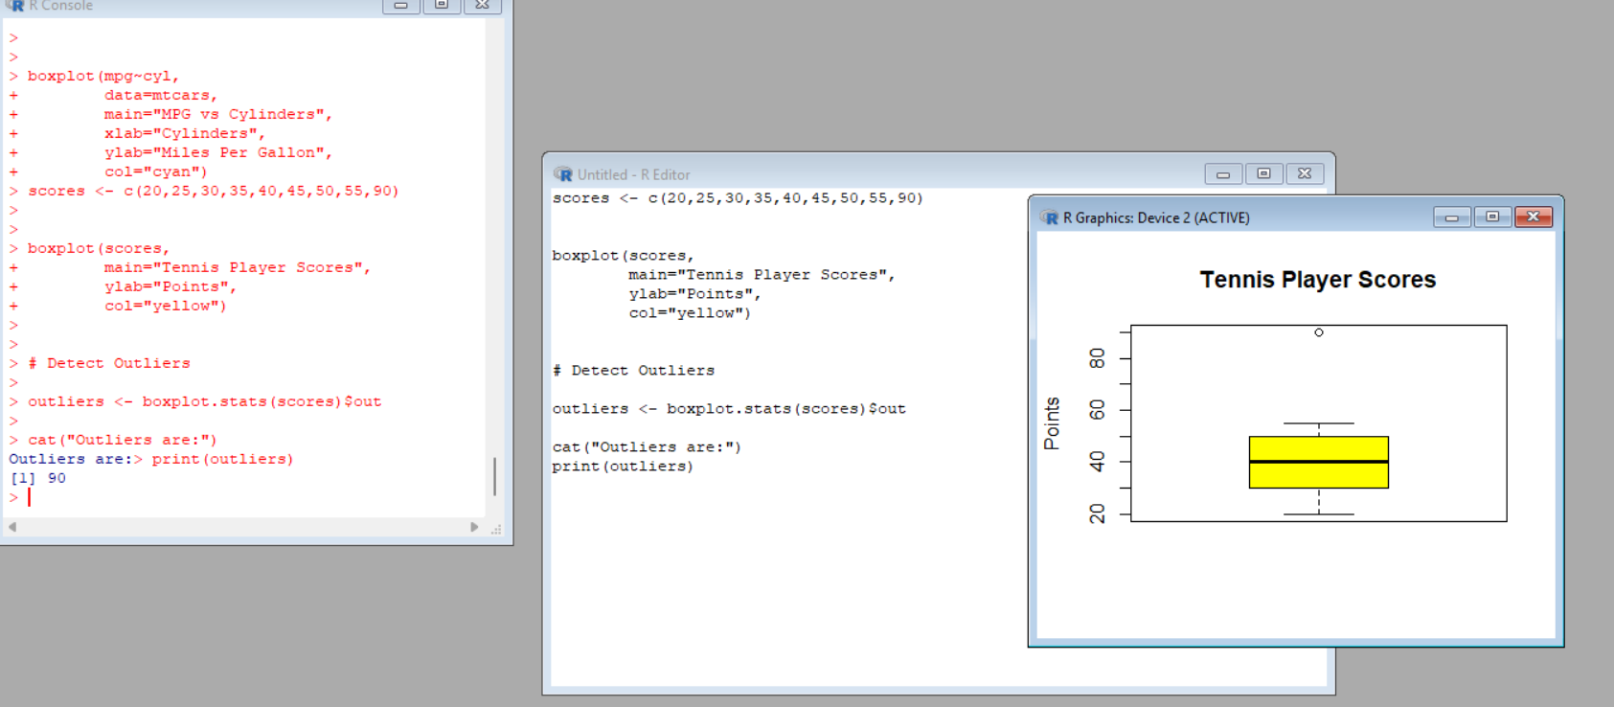
PROGRAM.10
# Diabetes Dataset Analysis in R

# Step 1: Load dataset
diabetes <- read.csv("diabetes.csv")

# Step 2: Inspect dataset
head(diabetes)
str(diabetes)

# Step 3: Scatter Plot
plot(diabetes$Age,
diabetes$BloodPressure,
main = "Blood Pressure vs Age",
xlab = "Age",
ylab = "Blood Pressure",
col = "blue", pch = 19)

# Step 4: Bar Chart
avg_bp <- aggregate(BloodPressure ~ Age,
data = diabetes,
mean)

barplot(avg_bp$BloodPressure,
names.arg = avg_bp$Age,
main = "Age vs Average Blood Pressure",
xlab = "Age",
ylab = "Average Blood Pressure",
col = "green")

OUTPUT:
